Edgeworth Public School

Preschool Family Handbook

2019
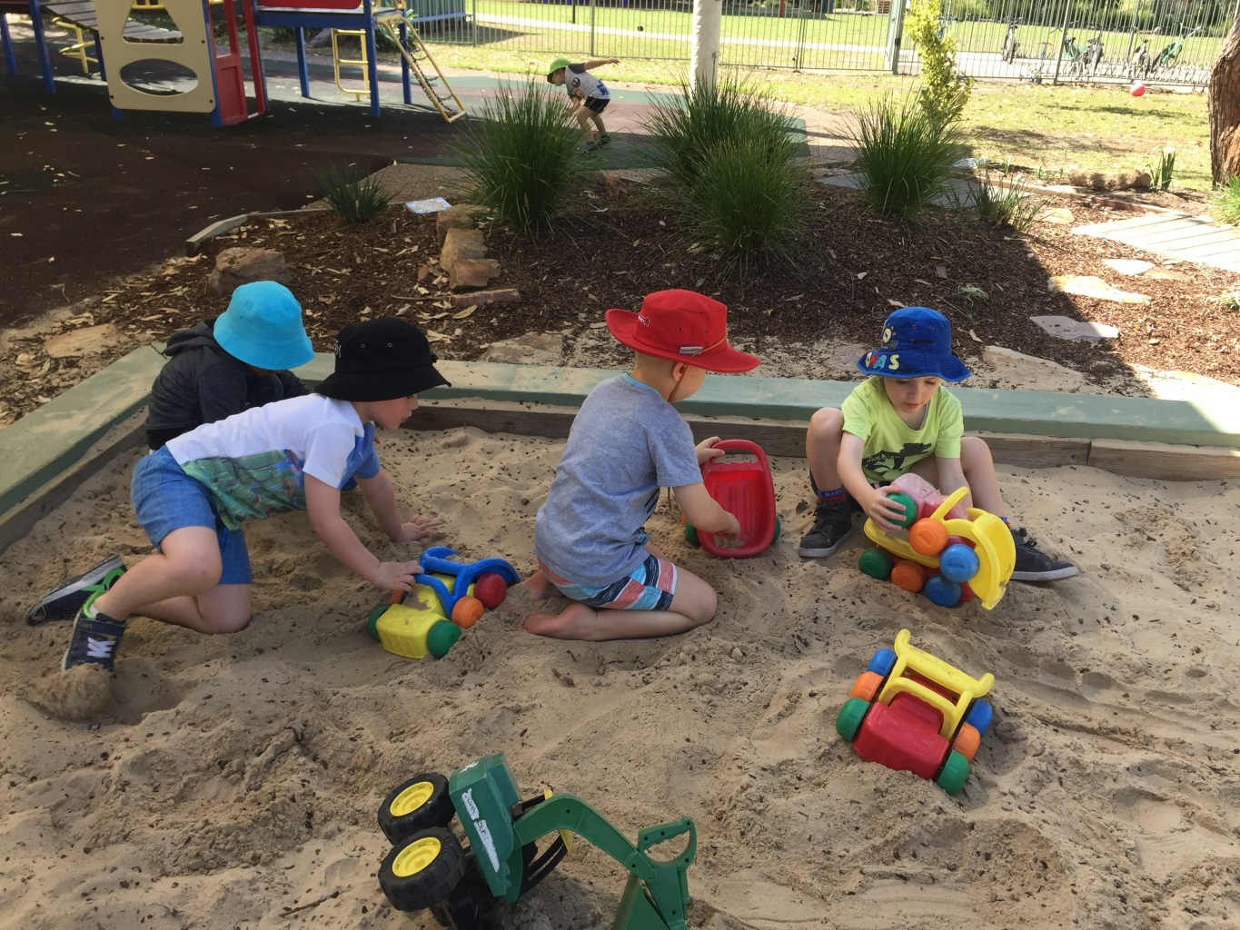

Principal’s Welcome Message
We are delighted to welcome you to Edgeworth Public School Preschool. Our staff are highly qualified and dedicated to bringing about the best possible outcomes for your children. Edgeworth Public School Preschool implements a learning curriculum that aligns with the Early Years Learning Framework (EYLF). Children learn through play-­‐based activities and intentional teaching that develops their understanding of ‘being, belonging and becoming’. Staff continually assess children’s development and adjust their programs according to student developmental needs. We look forward to joyful and successful preschool and primary school years working with you and your children as they grow in confidence and go from strength to strength as young people and learners.
Todd Osland

Edgeworth Public School and Preschool Contact Details

School Contact Details
- Principal: Todd Osland
- Deputy Principal: Rebecca Baird
- Preschool Staff: Claire Callinan
Jennifer Mitchell
- School Phone number: (02) 4958 1831
- Preschool phone: (02) 4958 8532
- Email: edgeworth-p.school@det.nsw.edu.au
- Website: www.edgeworth-p.schools.nsw.edu.au

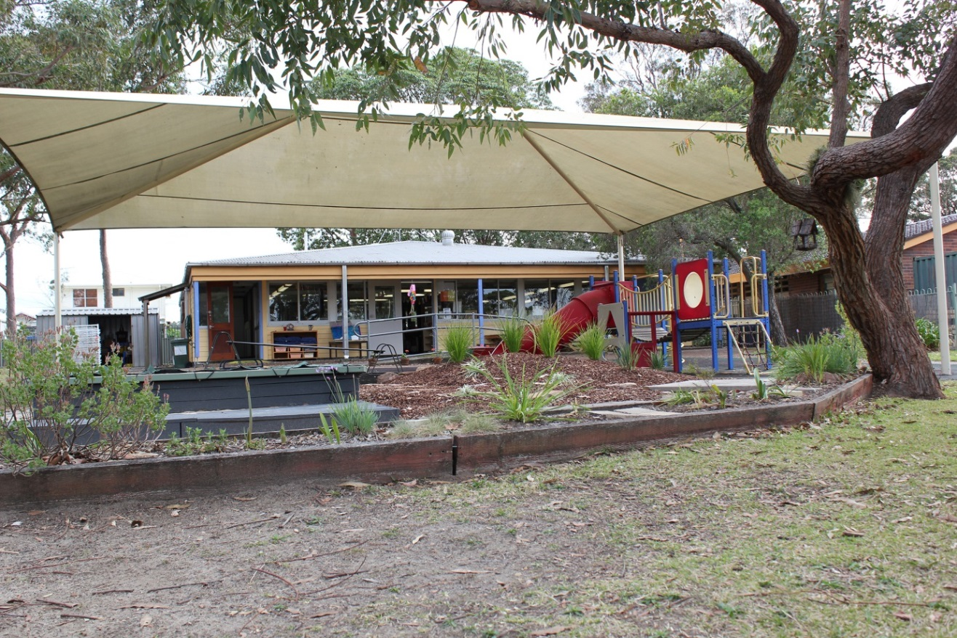

Edgeworth Public School Preschool Philosophy

Edgeworth Public School Preschool is a valued part of Edgeworth Public School situated on land traditionally owned by the Awabakal people between Lake Macquarie and the Sugarloaf Range. We believe that the culture and heritage of each child attending the preschool should be reflected in our program.
At Edgeworth Public School Preschool we uphold the following beliefs about:

The Child...
Each child is an individual with their own unique experiences, culture, values, beliefs, interests, strengths and needs.
Each child is a competent and capable learner who has the right to access a quality early learning program which allows them to develop at their own rate towards their full potential as a life-long learner.
Each child’s learning is optimised when they feel supported within a quality learning environment in which BEING a child is valued.

The Family...
The family is a child’s first educator, each bringing their own culture, values and expectations to the learning environment where diversity is celebrated and respected.
The family provides a child’s early opportunities for developing a sense of BELONGING.
We recognise that part of our role as educators is to contribute information and support for families to meet their child’s individual needs for holistic development. Ensuring authentic, respectful communication between families, educators and outside agencies is paramount in maximising each child’s learning within our setting and beyond.

Program and Practice...
Educators recognise our early opportunity to build strong learning foundations for children and their family. The Early Years Learning Framework focusing on Belonging, Being and Becoming, and the National Quality Standard underpin our program and practice.
The program is guided by the children’s culture, interests, strengths and needs and evolves through an ongoing cycle of observation, intentional provision, spontaneous experiences and reflection.
Educators recognise the importance of ongoing professional learning and reflection as part of our commitment to best practice and continuous improvement.

Learning...
We recognise the importance of play for children to “learn by doing”, BECOMING inquiring learners through intentional provisions which extend individual interests and needs as well as spontaneous experiences.
All children have access to participate in learning opportunities according to their individual interest, abilities, strengths and needs guided by quality educators through effective planning and reflective practice.
We recognise and celebrate the nature of young children as uninhibited, inquisitive, enthusiastic learners who are nurtured through caring, consistent relationships with educators.

The Learning Environment…
We believe that children learn best within a welcoming environment which is supportive and nurturing to children and families. It should stimulate the desire to engage, explore and encourage a willingness to take measured risks as a learner within a safe, happy environment. Meaningful communication, respectful interactions, laughter and joy are valued.
Educators recognise our role in maintaining an engaging, sustainable and natural environment while remaining mindful of the importance of incorporating technology for learning and life.

Relationships within the Learning Community...
We recognise our early opportunity to provide a positive introduction to the learning community of Edgeworth Public School in which participation and inclusion are valued.
Building and supporting positive, respectful, equitable relationships between children, families, educators and the wider community fosters a sense of BELONGING for all participants.
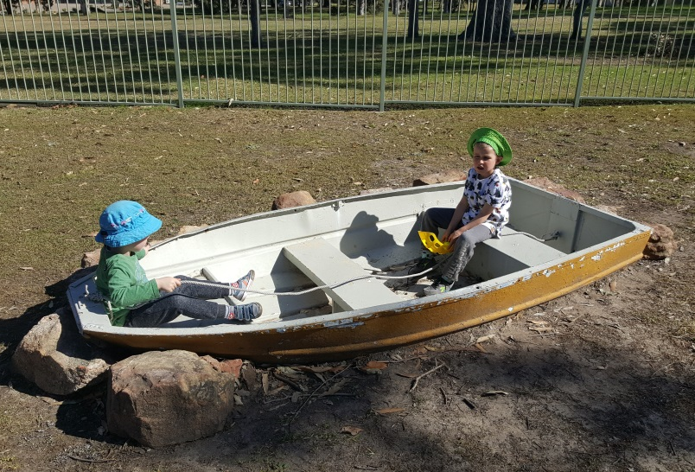
We believe that having positive experiences as learners build participants’ self- esteem, resilience and the desire to contribute positively to the learning community in the future.

What happens at Preschool?

Preschool Hours
Our preschool program operates 1 full-­‐time classroom with two groups of up to 20 children.
Current structures:
15 hours a week:
Group 1 attend every Monday and Tuesday from 9.10am to 3.10pm and on alternate Wednesdays from 9.10am to 3.10pm.
Group 2 attend every Thursday and Friday from 9.10am to 3.10pm and on alternate Wednesdays from 9.10am to 3.10pm.

Arrival time

Our preschool sessions commence at 9.10am and children should arrive on time so they don’t miss important activities at the beginning of the day. It is important that children are brought to and collected from preschool by a responsible adult. Preschool children (and their siblings) must be fully supervised by an adult before preschool starts (and also after it finishes). Children must not be left unattended in the playground or preschool classroom at any time.
The preschool staff cannot accept responsibility for children before 9.10am as we have other duties and need to prepare the program for the day ahead. However we will always make time available if you need to see us about anything urgent at this time.
Before you come inside please encourage your child to put their drink and food containers into the baskets provided. We like to encourage independence and responsibility right from the start!
It is most important that you ‘hand over’ your child to the staff each morning and not just drop them off without seeing a staff member first. To help your child have a great start to the day please come into the room and help your child choose an activity. When you are ready to leave please make sure you say goodbye to your child. Even though this can be a distressing time for your child it is important that you say a proper goodbye. Staff will be on hand to support your child through this separation process.
Access to preschool is via the front gate. This gate has a childproof latch on it and must be kept closed AT ALL TIMES. Please make sure that children do not swing on the gate or go out the gate without an adult accompanying them, especially during arrival and departure times. The car park can be very busy and poses a risk to safety, so please hold your child’s hand when entering and leaving the preschool and walking through the car park and driveways.

Collection time
The Preschool session finishes promptly at 3.10pm. It is most important that you are on time to collect your child, as children can become quite distressed if their parents are late. Please arrive a few minutes before 3.10pm so you are ready to collect your child as soon as preschool ends.
If you are unavoidably delayed please phone and let us know so we can reassure your child that you will be coming soon. At the end of the day staff will farewell the children individually when they see that their parent/carer has arrived. This way we can pass on important information about your child’s day.
Children can only be collected by their parents or guardians or another adult who has been given your written authority to collect your child. You will need to fill out an “Authority to Collect” form if anyone else collects your child. In an emergency you may phone staff to authorise someone else to collect your child but you will need to provide staff with their contact details and we will ask them for identification when they arrive.
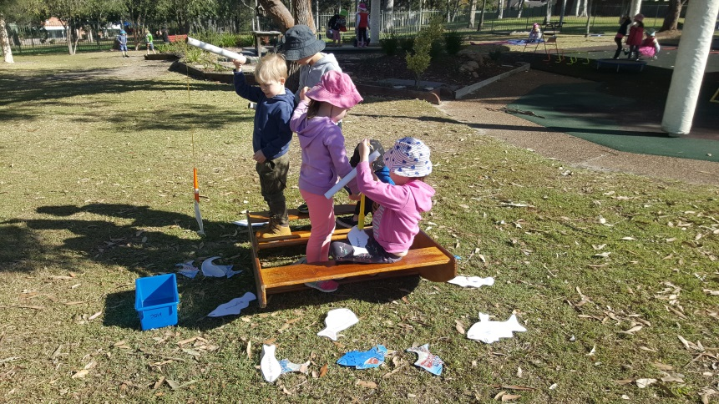

Update changes of contact details
Please let us know in writing, if any of your child’s enrolment details change such as new address or phone numbers or changes to emergency contacts etc. It is vital that we have correct details in case we need to speak to you urgently.

Phone contact during session
The preschool phone number to contact us during session times is 4958 8532. You are welcome to call during the session if you need to check how your child is or to pass on urgent messages. You will also need to phone to let us know if your child is ill or if someone else will be collecting them that day. If you wish to discuss any other issues it is best to speak with, or phone, staff at the end of the session or during staff release time when we can give you more time and attention.
If necessary you can contact Edgeworth Public School office on 49581831 and they can relay a message to us.

Please label everything
Everything that your child brings to preschool needs to be labelled clearly with his/her name to avoid loss and confusion as many clothes, bags, lunch boxes and drink bottles look alike. It also helps children learn name recognition if their belongings are clearly labelled and will ensure we can return ‘lost’ items.

Toileting
It is important that your child is able to manage toileting independently before starting preschool. However we do realise that individual needs and toileting skills vary greatly and toileting accidents may happen from time to time. Please let us know if your child needs extra reminders or assistance with toileting and remember to provide additional spare underpants and clothing (also clearly labelled).

Appropriate clothing/footwear
Please remember to pack a complete change of clothes for your child, as accidents and mess can happen. In cooler weather children will need a warm jacket or coat for outdoor play.
Children should wear comfortable, casual clothes that are easy to move in and easily washed. Children will need to wear shoes that are safe for running and climbing in e.g. sneakers or sandals. Edgeworth Preschool is a SunSmart school which means we require children to wear a protective sunhat at all times when outdoors.

No gum boots, thongs, crocs, slippers or backless shoes.

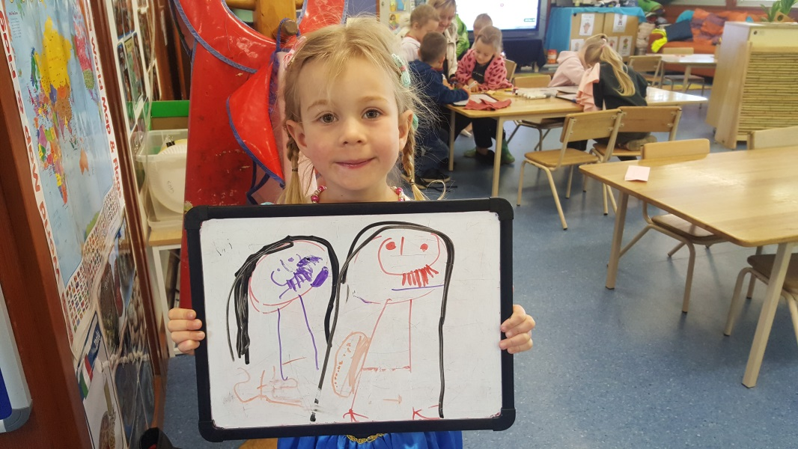

Sunscreen and hats for outdoor play
As part of our Sun Protection Procedure all children must wear a hat which protects their face and neck from the sun, during outdoor play.

Parents are responsible for putting sunscreen on their own child in the morning before coming to preschool. For sun protection we also recommend that children wear clothing which covers their shoulders and necks eg no singlet tops or strappy sundresses et

Communication
Our school recognises the importance of a positive parent/staff relationship. We encourage:
- sharing knowledge to enhance the growth and development of your child
- developing positive relationships with families that are based on mutual trust and open communication
- developing a sense of belonging to the preschool for the children, parents and staff.
- Important notices are placed on the preschool noticeboards outside, in our parent room and/or distributed individually. Preschool newsletters are produced on a monthly basis providing information about what is happening within the preschool.
- Parent meetings are held throughout the year for your input and feedback.
- Parent interviews are held at the end of term 2 and throughout the year as required.
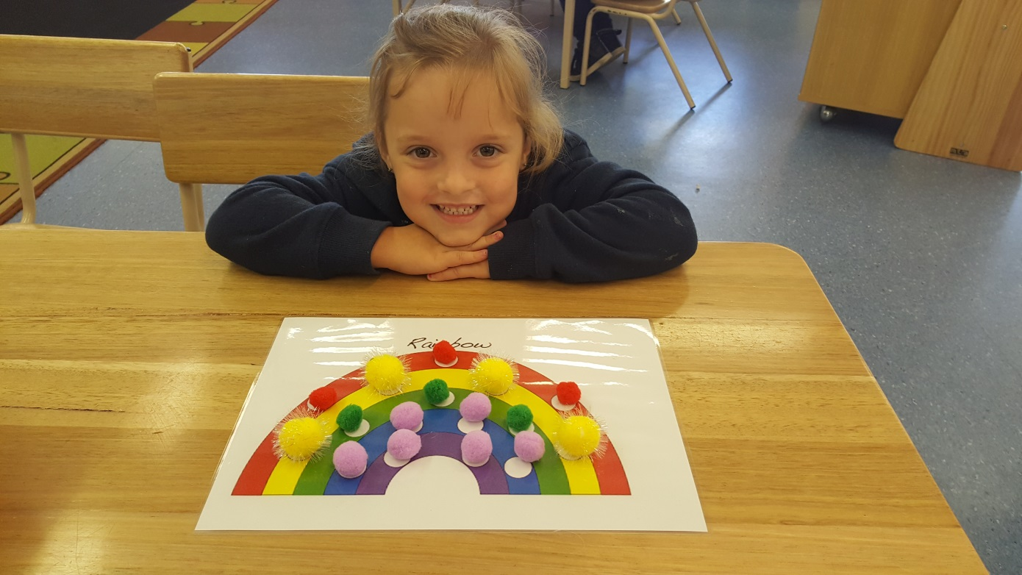
- Teachers appreciate the opportunity to talk with parents and carers both formally and informally. This ensures valuable insights and understandings can be appreciated about a child’s individual developmental journey. If you have any questions or concerns, please do not hesitate to ask for an appointment to meet with the teacher.

Bringing items from home
To avoid the risk of precious things getting lost or broken we ask that children do not bring in toys from home unless it is a special occasion and you discuss it with staff first.
We also welcome donations of blank paper, envelopes, writing paper, old greeting cards, useful junk, ice cream, yoghurt and take away food containers, empty boxes (small) for craft, old wrapping paper, scraps of material etc and any other items you think we could use on our craft trolley. (NB no toilet rolls please as they can pose a health risk).

Information displays
Please check the noticeboards in our parent area for the latest preschool news. Information about what is happening at preschool and various community events will be displayed.

Library borrowing
To promote literacy skills and encourage a love of books and reading, preschool Library borrowing will commence in Term 1.
To borrow books your child will need to bring a separate library bag to put their books in to avoid any damage in transit. Children may borrow and return books on any preschool day.
Parents record the books being borrowed and returned in the library folder on top of the bookshelf.

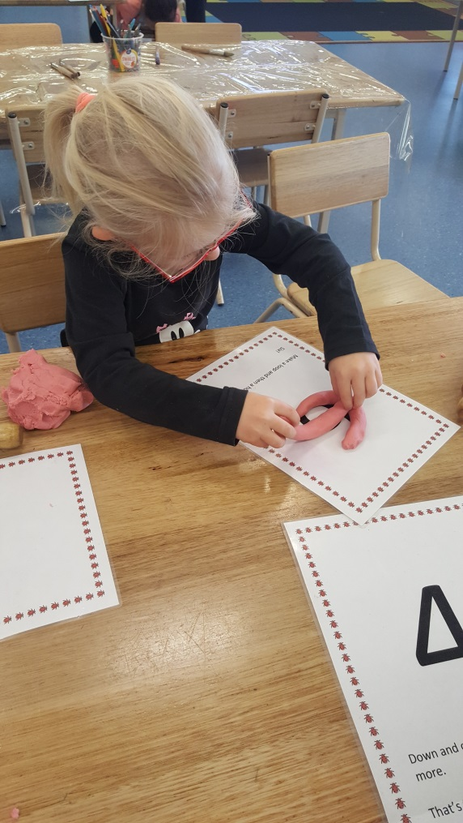
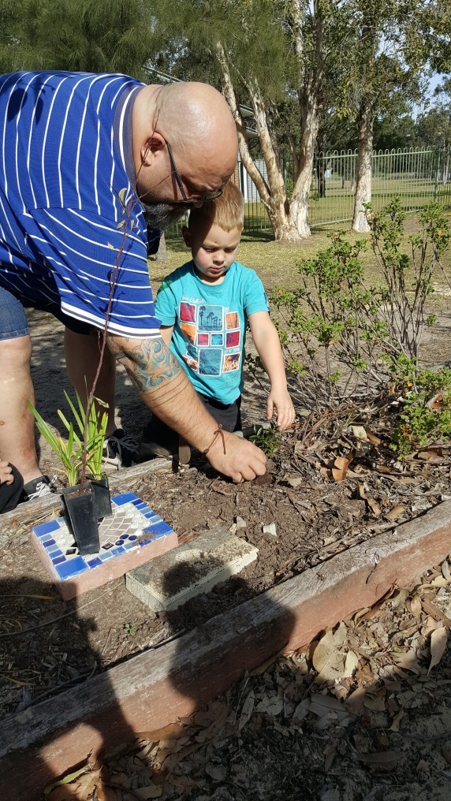

Edgeworth Public School Preschool Curriculum
The National Early Years Learning Framework (EYLF) for children from birth to five years has been developed for use by all early childhood services across Australia. The Early Years Learning Framework for Australia (EYLF) is a guide for early childhood educators who work with children from birth to five years. The EYLF has been developed to ensure your child receives quality education programs in their early childhood setting as this is a vital time for their learning and development. The EYLF is implemented in partnership with families (who are children’s first and most influential educators), to develop learning programs which are responsive to children’s ideas, interests, strengths and abilities, and recognises that children learn through their play.

The Framework‘s vision is for all children to experience play-­‐based learning that is engaging and builds success for life. http://www.deewr.gov.au/Earlychildhood/Programs/EarlyChildhoodEducation/Pages/default.a spx

The Early Years Learning Framework describes childhood as a time of Belonging, Being and
Becoming.
- Belonging is the basis for living a fulfilling life. Children feel they belong because of the relationships they have with their family, community, culture and place.
- Being is about living here and now. Childhood is a special time in life and children need time to just ‘be’—time to play, try new things and have fun.
- Becoming is about the learning and development that young children experience. Children start to form their sense of identity from an early age, which shapes the type of adult they will become.
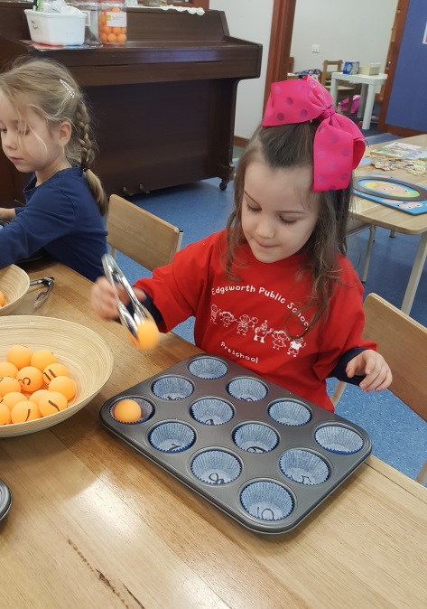
The following outcomes from The Early Years Learning Framework describe the learning and development of children at Edgeworth Public School Preschool:
- Children have a strong sense of identity
- Children are connected with and contribute to their world
- Children have a strong sense of wellbeing
- Children are confident and involved learners
- Children are effective communicator

Participating and contributing to our preschool

Contribution to decision making.
Families are welcome to contribute to the decision making procedures of the school through the P&C committee. The P&C plays an important role within the school. Meetings are twice a term. Dates and times are advertised in the newsletter. All parents are encouraged to attend the meetings. As well as its more official activities, the P&C provides an informal meeting ground for parents and teachers and serves a fundraising function for the School.

Participation in preschool activities
Families are welcome to share their special skills, interests and diverse family cultures with the preschool and are encouraged to participate in social activities to enable them to meet other families and form a sense of belonging to the school. Families can help in the following ways:
- sharing knowledge and expertise of craft, cooking, music, storytelling, job skills etc.
- participating in the daily program
- assisting with laundry, working bees in the garden etc.

Preschool Fees
Preschool fees have been mandated by the State Government at $15.00 per day. Fees are to be paid at least a fortnight in advance, either weekly, fortnightly or by the term at the school office. EFTPOS and Parent Online Payment (POP) facilities are available. Regular EFTPOS payment plans can be arranged through the school office. If families experience difficulty making routine payments, adjustments to fees can be made under certain circumstances in consultation with the Principal. As our service provides education within school hours, families are unable to claim Child Care Benefit or Child Care Rebate for fees.

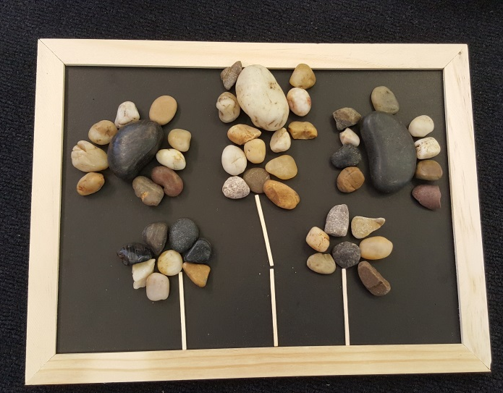

Student wellbeing, health and safety

Student Welfare and Management
At Edgeworth Public School we value that everyone is an individual and that we all have the special qualities that make us who we are. It is important that students are treated with respect by valuing their uniqueness and what they bring to the school. We provide a supportive, welcoming and culturally inclusive educational environment where students feel safe and happy. The school has a Student Wellbeing policy that outlines the steps for addressing student welfare and management issues.

Emergency management procedures.
The school has a policy on emergency evacuations and is required to practise evacuation procedures. All staff and children participate regularly throughout the year.

Food and drinks at preschool
We encourage children to bring simple nutritious fresh foods to eat at preschool and to not bring processed or pre-­‐packaged food. Each child will also need to bring a drink bottle filled with water only (no juice or other drinks please).
Get Up and Grow” recommends that, as a guide, foods should contain less than:
- 20 g fat per 100 g
- 15 g sugar per 100g
- 600 mg salt per 100g

Food which does not meet these guidelines will be sent home for afternoon tea and a healthier alternative offered. Parents are requested to use these dietary guidelines when choosing foods for preschool meals.
Please pack morning tea and lunch foods in two separate containers so your child can easily find them. Drink and food containers should be easy for your child to open and close and must be clearly labelled with your child’s name.

Due to the high incidence of peanut and related allergies in today’s society, parents are requested to avoid sending nut-based foods to preschool e.g. peanut butter, Nutella, nuts or food prepared in peanut oil

Food safety tips for homemade lunches and snacks
Provision is made for the children to eat during the preschool session. Parents/carers are urged to provide children with healthy snacks and lunch which will enable the staff to assist in the development of lifelong healthy eating habits. All children will need their own drink bottle with water only. Healthy lunches, snacks and drinks are important for children and help with their concentration and learning.
School lunches however are particularly susceptible to food poisoning, especially in the summer heat. Parents and care-­‐givers are reminded of a few simple food safety rules to prepare safe and healthy school lunches and avoid the growth and contamination of food poisoning bacteria.
- Before handling food, wash hands with soap and warm running water and dry thoroughly. Lunch boxes and eating utensils should also be washed thoroughly before reuse. Children should also be encouraged to always wash their hands before eating.
- Foods that are prepared the night before, such as sandwiches, should be frozen overnight and then taken out for each day’s school lunch. Suitable foods to freeze are: bread, cooked meat, cheese, baked beans or vegemite.
- Because food is normally stored in a child’s lunch box for several hours, the lunch box needs to be kept cool. This can be done by:
- choosing an insulated lunch box or one with a freezer pack, or include a wrapped frozen water bottle to keep the lunch box cool
- perishable foods such as dairy products, eggs and sliced meats should be kept cool, and eaten within about four hours of preparation. Don’t pack these foods if just cooked; first cool in the refrigerator overnight.
- if including leftover meals such as meats, pasta and rice dishes, ensure you pack a frozen iceblock into the lunch box
- water bottles can be frozen overnight and then stored in your child’s lunchbox, helping to keep it cold.
While at school children should keep their lunches in cool places and away from direct sunlight and other heat sources that facilitate the development of food poisoning bacteria.

Physical activities
Physical activity is very important for children and opportunities are provided daily at preschool for structured and unstructured physical activity.
During the preschool sessions, your child will be involved with some hands on experiences both inside the classroom and in the outdoor area. These activities can, at times, be very messy.
Please ensure your child is dressed appropriately so that they feel confident to participate in all the challenges provided throughout the session. In keeping with the sun safe policy, children will need to wear a suitable hat. A warm coat and hat is required in winter. The children will be challenging themselves on the climbing equipment so sensible footwear is essential and long dresses and skirts can be dangerous. Please label all of your child’s clothing and pack a spare set in case of extremely messy play or accidents.

Health and medical condition management

Immunisation
Children are unable to be enrolled at the preschool without proof of their current immunisation status. The National Quality Standard requires the preschool to maintain records of children’s immunisation status. Parents are requested to provide an updated copy of the children’s immunisation records from Medicare for our records after they receive boosters through the year.
Medical conditions and Accidents
It is important that sick children are kept at home for their own comfort as well as the comfort and health of other children and staff. If a child becomes ill or is injured at school, appropriate First Aid will be given and if necessary parents will be notified and asked to take their child home. If emergency treatment is required parents will be notified immediately and the child will be transferred by ambulance to hospital. In such cases ambulance services and treatment are free. All students who have an ongoing condition (eg asthma, diabetes, epilepsy, anaphylaxis) must have a treatment plan completed by parents and their GP and lodged at the school. Health Management Plan proformas are available from the front office or from a staff member in the preschool.
If a child is to take a prescription medicine while at school you must provide written directions from a medical practitioner and the medication in its original container clearly identified for your child. Medication must be handed to staff at the beginning of each day for safe storage and a medication form must be completed by the parent. Information on a child’s health status eg epilepsy, diabetes, should be given on enrolment or on diagnosis. If the health problem is serious please provide an up to date photograph of the child so it can be placed on our Medical Alert board.

Anaphylaxis and allergy management
Edgeworth Public School Preschool is an allergy aware school due to the inclusion of students and staff members with life threatening anaphylactic allergic conditions. We ask that anyone entering the preschool site washes their hands on arrival and ensures that they do not bring any nuts (or any foods or items containing any nut products) to the preschool or school. Please advise staff if your child has any allergies and complete the required Allergy and Anaphylaxis Management Plan for your child. Further information will be provided at the start of each year regarding other allergies that may be present and other foods that may not be brought to Preschool or school. Your co-­‐operation is vital for this important health and safety matter.
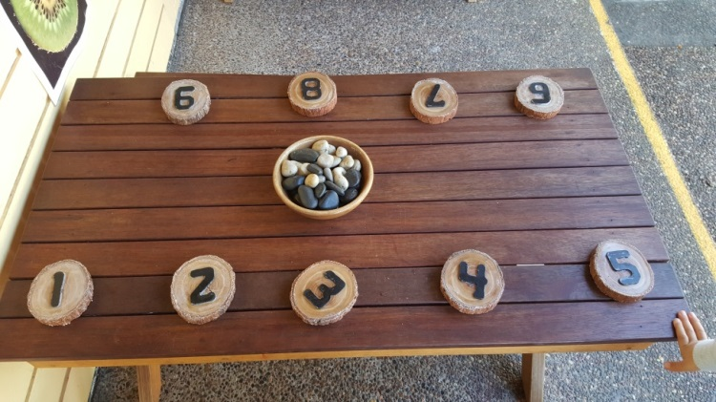

Hygiene and handwashing procedures.

Staff, children and volunteers must adhere to the hand washing procedures. All children are encouraged to wash their hands:
- before and after eating or touching food
- after toileting
- after blowing their nose and wiping tears and dribbles
- when leaving the preschool.
All scratches and cuts must be covered.

Diseases outbreak procedures and exclusion periods
Personal hygiene measures such as hand washing, covering the mouth and nose when coughing or sneezing, covering weeping sores, not sharing food or drinks and not attending school when ill or suffering from diarrhea are important means of limiting the transmission of a number of common infectious conditions.
The NSW Public Health Regulations require children with the following conditions, and children who have been in contact with the following conditions, to be excluded from school, Preschool, child care or family day care for the period specified in the table below.

Condition Usual time between Infection, Illness & return

Chicken Pox 11-20 days. Minimum exclusion 5 days after spots appear
German Measles (Rubella) 14-21 days. Minimum 6 days after Rash appears.
Glandular Fever Until recovered
Hepatitis A 15-50 days, 7 days from onset of jaundice
Hepatitis B Medical certificate required
Measles 7-14 days. 5 days from rash appearing
Mumps 12-22 days. Return one week after appearance of swelling
Impetigo 5-21 days, Consult doctor. If sores treated & covered, return to school permitted
Pediculosis (Head Lice) Eggs hatch in 1 week reach maturity in 2 weeks
Ringworm 10-14 days
Scabies Several days - sometimes weeks
Whooping Cough 6-20 days, If antibiotic treatment not given, 3 weeks from onset of
whoop. If oral erythromycin given, 5 days from start of medication.
Source www.health.nsw.gov.au

Notes and Additional Information

